Course 5 (Capstone)

Week 4 assignment

Part2

--AQ1: Cumulative quantity for locations

select W_LOCATION_D.location_Id

,W_LOCATION_D.location_name

,W_SALES_CLASS_D.sales_class_ID

,W_SALES_CLASS_D.sales_class_desc

,W_TIME_D.time_year

,W_TIME_D.time_month

,W_SALES_CLASS_D.base_price

,sum(W_JOB_F.QUANTITY_ORDERED) as Sum_Qty_Ord

,sum(W_JOB_F.QUOTE_QTY)as sum_amount

,SUM(SUM(W_JOB_F.QUOTE_QTY)) OVER (PARTITION BY W_LOCATION_D.location_Id,W_TIME_D.time_year

ORDER BY Time_Year

ROWS UNBOUNDED PRECEDING ) AS CumSumAmount

from w_JOB_F,w_location_D,w_sales_class_D,W_TIME_D

where w_location_d.location_id = w_job_f.location_id

and W_SALES_CLASS_D.SALES_CLASS_ID = w_job_f.SALES_CLASS_ID

and W_TIME_D.time_ID =CONTRACT_DATE

Group by W_LOCATION_D.location_Id

,W_LOCATION_D.location_name

,W_SALES_CLASS_D.sales_class_ID

,W_SALES_CLASS_D.sales_class_desc

,W_TIME_D.time_year

,W_TIME_D.time_month

,W_SALES_CLASS_D.base_price

order by W_TIME_D.time_year;

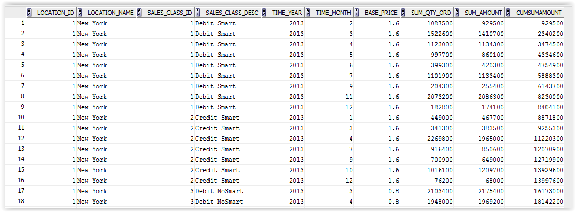

--AQ2: Moving average of average amount ordered for locations

select W_LOCATION_D.location_Id

,W_LOCATION_D.location_name

,W_SALES_CLASS_D.sales_class_ID

,W_SALES_CLASS_D.sales_class_desc

,W_TIME_D.time_year

,W_TIME_D.time_month

,W_SALES_CLASS_D.base_price

,sum(W_JOB_F.QUANTITY_ORDERED) as Sum_Qty_Ord

,sum(W_JOB_F.QUOTE_QTY)as sum_amount

,SUM(SUM(W_JOB_F.QUOTE_QTY)) OVER (PARTITION BY W_LOCATION_D.location_Id,W_TIME_D.time_year

ORDER BY Time_Year

ROWS BETWEEN 11 PRECEDING AND current row ) AS CumSumAmount

from w_JOB_F,w_location_D,w_sales_class_D,W_TIME_D

where w_location_d.location_id = w_job_f.location_id

and W_SALES_CLASS_D.SALES_CLASS_ID = w_job_f.SALES_CLASS_ID

and W_TIME_D.time_ID =CONTRACT_DATE

Group by W_LOCATION_D.location_Id

,W_LOCATION_D.location_name

,W_SALES_CLASS_D.sales_class_ID

,W_SALES_CLASS_D.sales_class_desc

,W_TIME_D.time_year

,W_TIME_D.time_month

,W_SALES_CLASS_D.base_price

order by W_TIME_D.time_year;

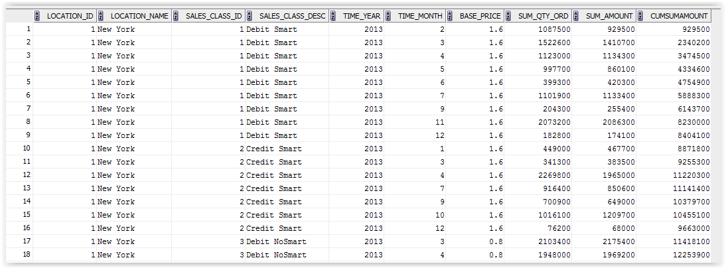

--AQ3: Rank locations by descending sum of annual profit

select BQ2.location_name

,BQ2.time_year

--,BQ2.time_month

,Sum_Invoice_Qty

,SumTotalCost

,sum(Sum_Invoice_Qty-SumTotalCost) as Profit

,RANK() OVER (PARTITION BY BQ2.time_year ORDER BY BQ2.time_year,sum(Sum_Invoice_Qty-SumTotalCost) DESC) AS Rank_Profit

from BQ2, BQ3

where BQ2.Location_ID=BQ3.Location_ID

Group by

BQ2.location_name

,BQ2.time_year

--,BQ2.time_month

,Sum_Invoice_Qty

,SumTotalCost

;

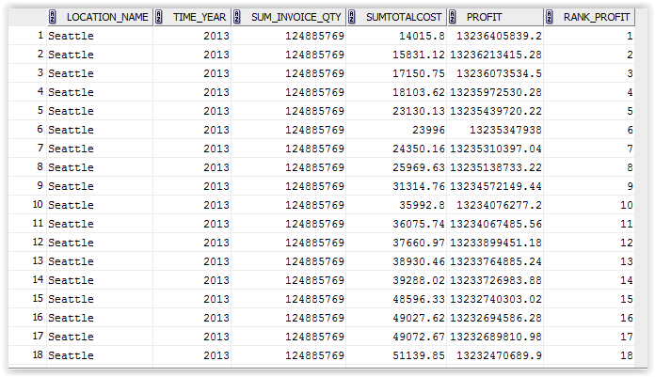

--AQ4: Rank locations by descending annual profit margin

select BQ2.location_name

,BQ2.time_year

--,BQ2.time_month

,Sum_Invoice_Qty

,SumTotalCost

,sum((Sum_Invoice_Qty-SumTotalCost)/SumTotalCost) as Profit_margin

,RANK() OVER (PARTITION BY BQ2.time_year ORDER BY sum((Sum_Invoice_Qty-SumTotalCost)/SumTotalCost) DESC) AS Rank_Profit

from BQ2, BQ3

where BQ2.Location_ID=BQ3.Location_ID

Group by

BQ2.location_name

,BQ2.time_year

--,BQ2.time_month

,Sum_Invoice_Qty

,SumTotalCost

;

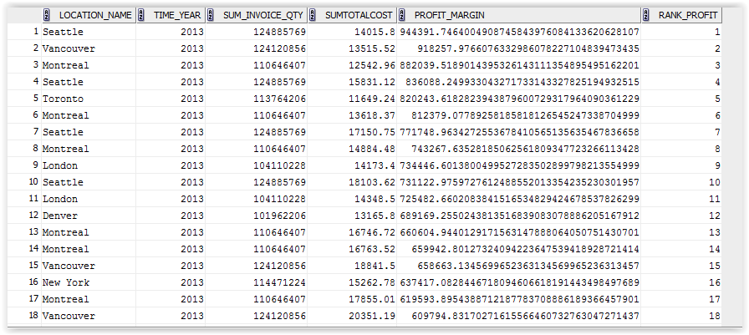

--AQ5: Percent rank of job profit margins for locations

drop view AQ5;

create view AQ5 as

select BQ2.Job_ID

,BQ2.location_name

,BQ2.time_year

,BQ2.time_month

,Sum_Invoice_Qty

,SumTotalCost

,sum((Sum_Invoice_Qty-SumTotalCost)/SumTotalCost) as Profit_margin

,RANK() OVER (ORDER BY sum((Sum_Invoice_Qty-SumTotalCost)/SumTotalCost) DESC) AS Rank_Profit

from BQ2, BQ3

where BQ2.Location_ID=BQ3.Location_ID

Group by

BQ2.Job_ID

,BQ2.location_name

,BQ2.time_year

,BQ2.time_month

,Sum_Invoice_Qty

,SumTotalCost

;

select * from AQ5;

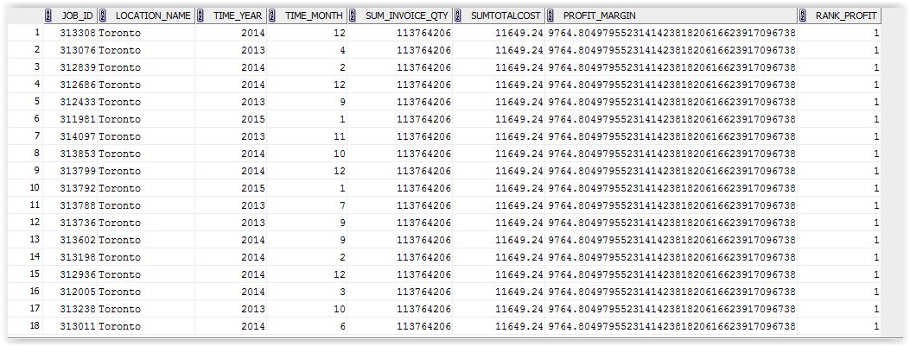

--AQ6: Top performers of percent rank of job profit margins for locations

select Job_ID

,location_name

,time_year

,time_month

,Profit_margin

,PERCENT_RANK()

OVER (ORDER BY Profit_margin) As pct

from AQ5

--WHERE pct >= 0.95

;

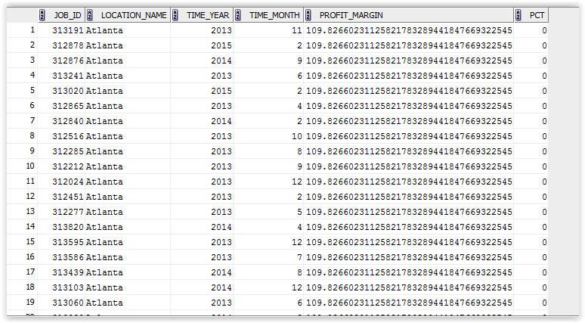

--AQ7: Rank sales class by return quantities for each year

Select SALES_CLASS_DESC

,TIME_YEAR

,SumQtyRtn

,SumDollarRtn

,RANK() OVER (partition by TIME_YEAR ORDER BY SumQtyRtn DESC) AS Rank_Class

from BQ4; 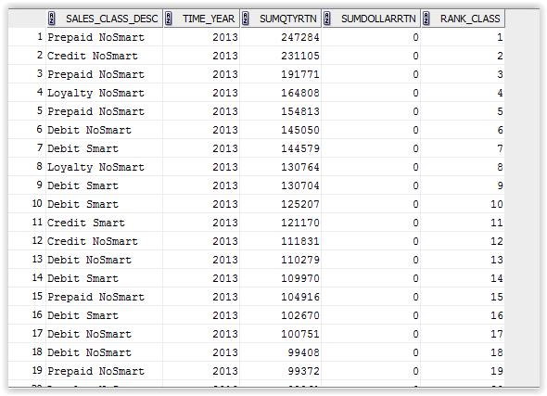

--AQ8: Ratio to report of return quantities for sales classes by year

Select SALES_CLASS_DESC

,TIME_YEAR

,SumQtyRtn

,SumDollarRtn

,RANK() OVER ( ORDER BY TIME_YEAR,SumQtyRtn DESC) AS Rank_Class

from BQ4;



--AQ9: Rank locations by sum of business days delayed for the job shipped by date (first shipment)

Select LOCATION_NAME

,W_TIME_D.TIME_YEAR

--, sum(BusDaysOff) as sum_delay_Days

,BusDaysOff

--,RANK() OVER (ORDER BY BusDaysOff DESC) AS Rank_Delay

from BQ6,W_TIME_D

Where W_TIME_D.TIME_ID = DATE_SHIP_BY

--Group by

--rollup (LOCATION_NAME,W_TIME_D.TIME_YEAR) ,BusDaysOff

; 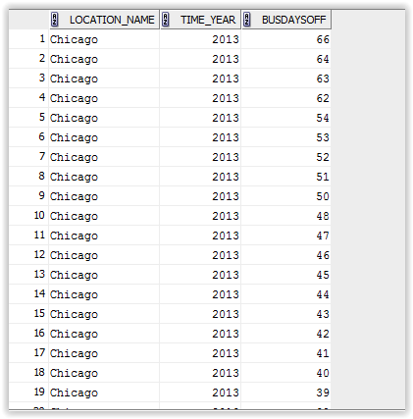

--AQ10: Rank locations by delay rate for jobs delayed on the last shipment date

Select LOCATION_NAME

, DATE_PROMISED

, Last_Shipment_Date

,QUANTITY_ORDERED

--, count(LOCATION_NAME) as delayed_Jobs

--, sum(BusDaysOff) as sum_delay

, BusDaysOff

from BQ5;

--group by rollup(LOCATION_NAME, DATE_PROMISED), Last_Shipment_Date,QUANTITY_ORDERED

--, BusDaysOff

group by LOCATION_NAME

, DATE_PROMISED

, Last_Shipment_Date

,QUANTITY_ORDERED

;

